Coronavirus Evolution and the Covid-19 Pandemic

Covid-19 is caused by a type of coronavirus that was discovered in 2019. Covid-19 is an acronym for Coronavirus disease discovered in 2019. By August 2022, Covid-19 had caused over 1 million deaths in the US and over 6 million deaths worldwide.

Where did the new coronavirus come from?
Scientists do not yet know how the new coronavirus originated. To learn about the main hypotheses, watch the video, “Where do new viruses come from?” (https://www.youtube.com/watch?v=NJLXdsO1GBI).

1a. What is a spillover infection?

1b. Give examples of diseases that have been caused by spillover infections in the past.

2a. This figure shows a cross-section of a coronavirus. Circle a spike protein (S).

2b. The spike proteins are one half of the Velcro mentioned in the video, and the other half of the Velcro consists of molecules on the surface of human cells. What happens after coronavirus spike proteins bind to molecules on the surface of a human cell?

Inside a cell, the coronavirus RNA is copied, and the genes in the coronavirus RNA give the instructions to make coronavirus proteins. Then, the coronavirus RNA and proteins combine to make new coronaviruses which leave the cell.

If a mistake occurs when the viral RNA is copied, the RNA copy will have a different sequence of nucleotides. This is called a mutation. This figure shows how a mutation in the viral RNA can result in a changed amino acid in the viral protein.  3. Mark the mutation with an asterisk (*). | 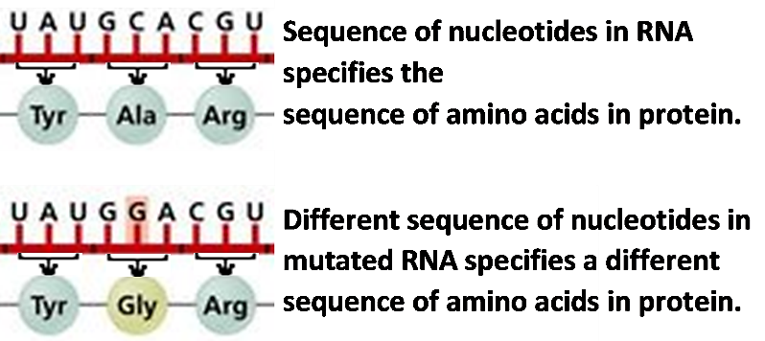

4. How do mutations in the spike protein gene contribute to a coronavirus spillover infection, e.g., from bats to humans?

This table lists three hypothetical versions of the spike protein gene in the coronavirus. The B version is the original version in bats; the H and N versions have mutations. The last two columns show the characteristics of the spike protein for each version of the spike protein gene. | Version of the  Spike Protein Gene | Spike protein can bind to molecules on the surface of
 |  | Bat Cells | Human Cells
 | B | Yes | No
 | H | No | Yes
 | N | No | No

5. Which version of the spike protein gene will result in a spike protein that will allow a coronavirus to enter a human cell to be reproduced by the cell? B ___ H ___ N ___

Lee was a curious child who liked to explore bat caves. The first row of this figure shows eight of the coronaviruses from a bat that entered Lee’s nose. Most of these coronaviruses had the B version of the spike protein gene. However, two of the coronaviruses had mutated versions of the spike protein gene (H and N).
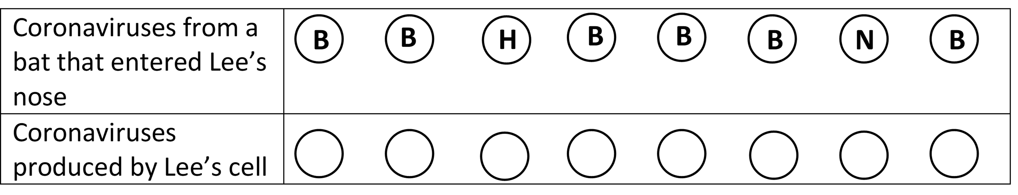
6a. In the top row of the figure, use X to cross out each coronavirus that has a version of the spike protein that would not bind to molecules on the surface of a human cell.

6b. Only one coronavirus in the top row could enter a human cell to be reproduced. Draw arrows from that coronavirus to the “Coronaviruses produced by Lee’s cell” in the bottom row. Label these coronaviruses with the version of the spike protein gene that they would have.

6c. These coronaviruses could infect other cells, which would produce thousands of coronaviruses with the ____ version of the spike protein gene.

This hypothetical example illustrates natural selection. Due to natural selection, a mutation that increases the ability of a coronavirus to enter a cell and be reproduced will become more common in a population of coronaviruses.

You have seen that mutations result in different versions of the spike protein gene, and natural selection increases the number of coronaviruses that have helpful mutations. Since mutations are random changes in the RNA, most mutations of the spike protein gene result in a spike protein that doesn’t bind well to molecules on the surface of either bat cells or human cells. Coronaviruses with this type of mutation would be eliminated by natural selection.

7a. Explain how mutations and natural selection can produce a spillover infection.

7b. Many types of animals are infected by coronaviruses, and many many mutations have occurred in the trillions of coronaviruses in these animals. Explain why most mutations of coronavirus genes do not result in spillover infections in humans.

How has the new coronavirus changed during the Covid-19 pandemic?

This graph shows the trends during 2020 in the percent of coronavirus RNA samples that had the G mutation in the gene for the spike protein. Before mid-February, less than 10% of samples had the G mutation. Four months later, almost all samples had the G mutation.  8. How do you think the G mutation became so common? | 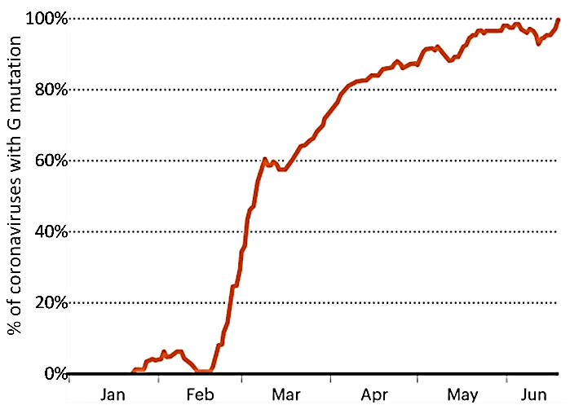

To better understand what happened, consider the figure below, which shows the spread of two hypothetical versions of the coronavirus. We assume that:
- Each person infected with the original (O) version of the coronavirus transmits the infection to one other person.
- Each person infected with coronaviruses that have the T mutation transmits the coronavirus infection to two other people. Thus, the T mutation doubles the rate of transmission.
The table on the right shows the increase in the percent of infected people who have the version of the coronavirus with the T mutation.
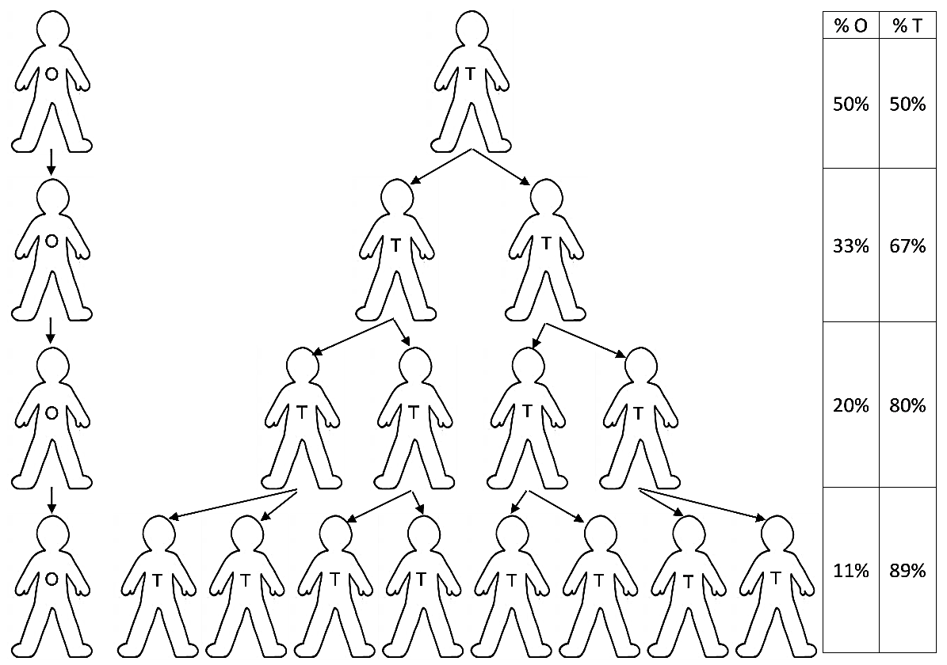

The actual G mutation in the spike protein gene increased the rate of transmission of coronavirus infections by about 20%. The changed amino acid in the G version of the spike protein allowed the coronavirus to enter human cells more easily.

9. Explain how the G mutation became so common.

A variant is a version of the coronavirus that has multiple mutations and spreads to many people. Since mutations are due to random errors in copying the viral RNA, most mutations and combinations of mutations reduce the coronavirus’s ability to infect people; these mutations are eliminated by natural selection. Rarely, a combination of mutations increases the ability of the coronavirus to infect people and spread from person to person; this can result in a variant that spreads widely.

So far, three variants have spread widely in the US – Alpha, followed by Delta, followed by Omicron. Different versions of the Omicron variant spread throughout the US during late 2021 and 2022. To understand how Omicron was able to spread so widely, you need to learn a little about human immune defenses.

Vaccination or previous coronavirus infection stimulate the production of antibodies and other
immune defenses against coronavirus infection.  10a. Some of the antibodies have the right molecular shape to bind to the spike protein of the coronavirus. How could these antibodies help to prevent a coronavirus infection? | 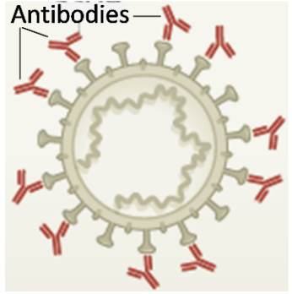
10b. The Omicron variant has multiple mutations in the gene for the spike protein. How could mutations in the spike protein gene decrease the effectiveness of antibody defenses against infection by the Omicron variant?

Mutations in the genes of the Omicron variant reduce the effectiveness of immune defenses against Covid-19. The most recent versions of the Omicron variant (e.g., the BA.5 subvariant) are particularly good at evading our immune defenses. Nevertheless, the immune defenses that result from vaccination generally prevent Omicron infections from becoming severe enough to cause hospitalization or death.

11a. When a person has a repeat Covid-19 infection, this is called a reinfection. When a vaccinated person has Covid-19, this is called a breakthrough infection. Explain why reinfections and breakthrough infections became more common as the Omicron variant and subvariants spread.

11b. Explain how Omicron’s ability to evade immune defenses contributed to the spread of Omicron across the world. (Hint: Remember that Omicron spread about two years after the pandemic began, when many people had been vaccinated and/or survived an infection.)

By Dr. Ingrid Waldron, Dept Biology, University of Pennsylvania. © 2022. A Word file and Teacher Notes with instructional suggestions and biology background are available at https://serendipstudio.org/exchange/bioactivities/coronavirusOrigin.

